**Saint Brigid Saint John the Baptist**

Palm Sunday of the

Passion of the Lord

March 25, 2018

**Catholic Church Catholic Church**

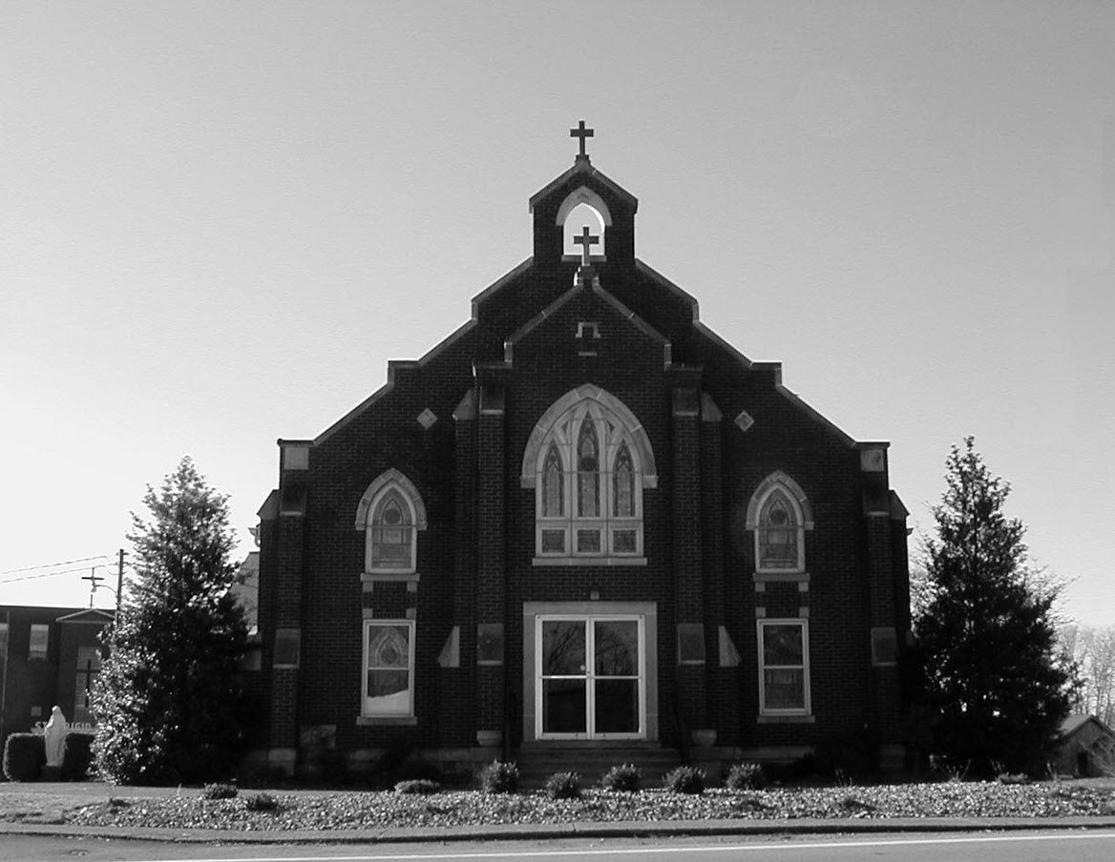

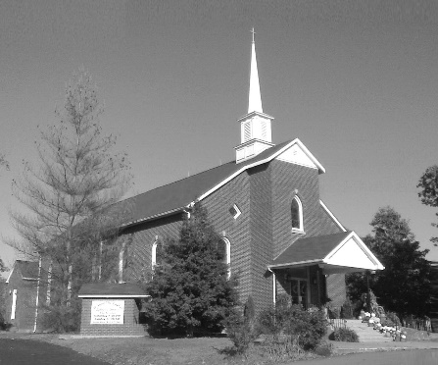

**Pastor:**

***Rev. Daniel L. Lincoln***

Rectory: (270) 877-2546

**Deacon:**

***Michael A. Ryan***

(270) 272-6789

314 E. Main St. 657 St. John Church Rd.

Vine Grove, KY 40175 Elizabethtown, KY 42701

Clustered Parish Office: Clustered Parish Office:

(270) 877-2461 (270) 877-2461

**ANNOINTING OF THE SICK:**

Notify the parish office when a family member is hospitalized.

**BAPTISM:**

Contact the parish office for information about the required preparation class.

**BULLETIN:**

Information must be submitted in writing by note or email to the parish office **no later than 12:00 noon on Wednesdays** for the following weekend. When sending an email, please put “BULLETIN,” and the name of the parish the announcement is for, in the subject line.

**MARRIAGE:**

Contact Father at least 6 months prior to the wedding date to complete required marriage preparations and to schedule the date.

**RCIA (Rite of Christian Initiation of Adults):**

Contact the Worship Chairperson for information.

**DEW MEMORIAL LIBRARY:**

(in St. Brigid Church basement):

Open: Sunday after 9:30 a.m. Mass& 45 minutes before all other Masses.

Email: [brigidvg@bbtel.com](mailto:brigidvg@bbtel.com)

Website:[www.stbrigidvg.org](http://www.stbrigidvg.org)

**Pastoral Associate & Dir. Dir. of Religious Education:**

**of Religious Education:** Lisa Thomas: (270) 735-6930

Deacon Mike Ryan (270 877-0546

**Youth Minister: Youth Ministers:**

Lori Law: (270) 723-0157 Angela Churchman:

(270) 268-9963

Ericka Finlay: (502) 612-2644

**MASS SCHEDULE:**

*Sunday:* 9:30 a.m. & 6:30 p.m.

*Monday:* 9:00 a.m.

*Thursday:* 9:00 a.m.

**RECONCILIATION:**

Sunday before Mass

5:30-6:00 p.m. or by appt.

**ROSARY:**

After weekday Masses

**PARISH COUNCIL MEMBERS:**

*President:* Sue Weisshaupt

*Vice-President:* Mike Bramlett

*Secretary:* Judy Cochran

*At-Large Members:* Blake Ryan

& Vincent Thompson

**CHAIRPERSONS:**

*Administration:* Dale Winchester

*Formation:* Tina Yates

*Parish Life:* Tom Billings

*Worship:* Keith Baughman

**MASS SCHEDULE:**

*Saturday (Vigil):*  6:30 p.m.

*Sunday:* 11:30 a.m.

*Wednesday:* 6:30 p.m.

*Friday:* 9:00 a.m.

**RECONCILIATION:**

Saturday before Mass

5:30-6:00p.m. or by appt.

**PARISH COUNCIL MEMBERS:**

*President:* Theresa Smith

*Secretary:* Karen Ray

**CHAIRPERSONS:**

*Administration:* Rick Newton

*Formation:* Ericka Newton

*Parish Life:* Bradley Wickersham

*Worship:* Nick Thomas



**Mass Schedule**

**Mass Schedule**

|  |  |  |  |  |  |
| --- | --- | --- | --- | --- | --- |
| **Saturday** | **March 24** | **6:30 p.m.** | **St. John** | **Phillip Thomas** | **Vigil: Palm Sunday of the**  **Passion of the Lord** |
| **Sunday** | **March 25** | **9:30 a.m.** | **St. Brigid** | **Don Rogers**  **Mack, Leanna & Billy Cecil** | **Palm Sunday of the**  **Passion of the Lord** |
| **“** | **“** | **11:30 a.m.** | **St. John** | **For All Parishioners**  **Bernard Osborne** | **“** |
| **“** | **“** | **6:30 p.m.** | **St. Brigid** | **Our Parish Family**  **Dickie Cecil** | **“** |
| **Monday** | **March 26** | **9:00 a.m.** | **St. Brigid** | **George Weeks**  **Louise Stith** | **Monday of Holy Week** |
| **Wednesday** | **March 28** | **6:30 p.m.** | **St. John** | **COMMUNION SERVICE** | **Wednesday of Holy Week** |
| **Thursday** | **March 29** | **9:00 a.m.** | **St. Brigid** | **CANCELLED** | **Holy Thursday** |
| **“** | **“** | **5:00 p.m.** | **St. Brigid** | **Margaret Skeeters** | **“** |
| **“** | **“** | **7:00 p.m.** | **St. John** | **For Special Intentions** | **“** |
| **Friday** | **March 30** | **5:00 p.m.** | **St. Brigid** | **COMMUNION SERVICE** | **Good Friday –**  **The Passion of the Lord** |
| **“** | **“** | **7:00 p.m.** | **St. John** | **COMMUNION SERVICE** | **“** |
| **Saturday** | **March 31** | **6:30 p.m.** | **St. John** | **CANCELLED** | **Holy Saturday –**  **Easter Sunday Vigil** |
| **“** | **“** | **8:30 p.m.** | **St. Brigid** | **Les, Magdalen, Charlie**  **& Tommy Buckman** | **“** |
| **Sunday** | **April 1** | **7:30 a.m.** | **St. John** | **For All Parishioners** | **Easter Sunday of the**  **Resurrection of the Lord** |
| **“** | **“** | **9:30 a.m.** | **St. Brigid** | **Our Parish Family**  **Will Yates** | **“** |
| **“** | **“** | **11:30 a.m.** | **St. John** | **Sid Vessels** | **“** |
| **“** | **“** | **6:30 p.m.** | **St. Brigid** | **CANCELLED** | **“** |

**INFORMATION FOR BOTH PARISHES**

**THANKS! THANKS!** – My “pacemaker recovery” is over. Thanks for the prayers, cards, meals and rides to and from for the past month. Fr. Dan

**ABORTION AND ADOPTION –** The number of would-be adoptive parents (of newborn babies) far outstrips the supply in America. Each year in the United States, about 135,000 American children are placed for adoption. Experts estimate somewhere between one and two million couples seek to adopt yearly. Every year, there are about 1.3 million abortions. Sadly, only 4% of women with unwanted pregnancies give their children up for adoption. Every child is wanted and wanted desperately! By Pro-Life Articles Author [www.pro-lifearticles.org](http://www.pro-lifearticles.org)

**PROJECT RACHEL** **–** Healing…Forgiveness…Hope…After the experience of an abortion. If you or someone you know is struggling with the pain from an abortion, please consider Project Rachel – a post abortion ministry. To speak to someone confidentially, call (502) 471-2155 or email [ProjectRachel@archlou.org](mailto:ProjectRachel@archlou.org).

**CONFIDENTIAL PREGNANCY AND ADOPTION COUNSELING** – is available at Catholic Charities for women of all ages experiencing untimely pregnancies. A full range of services are provided, including adoptive placement, legal assistance and counseling for individuals, groups and families. Post-abortion counseling is also available. Services are provided regardless of income or marital status. For more information, call Catholic Charities at (502) 637-9786.

**SAVE THE DATE** – Fr. John Judie will have a celebration of his retirement, 70th birthday and 31 years of priestly ministry on **Saturday, August 11, 2018**. More details will follow later. He may be reached at (502) 774-5772.

**The DIACONATE ORDINATION** **of Anthony Cecil, Steven Reeves, Kirby Rust** will be celebrated by Archbishop Joseph Kurtz on **Saturday, March 24, 2018 at 10:00 a.m.** at the Basilica of St. Joseph Proto-Cathedral in Bardstown. The people of the Archdiocese of Louisville are welcome and encouraged to attend this joyful celebration.For more information, contact Sr. Sarah Yungwirth at [**syungwirth@archlou.org**](mailto:syungwirth@archlou.org) or Kelly McLemore in the Vocation Office at 502-471-2122.

**Rite of Christian Initiation for Adults (RCIA)**

**Date: Thursday, March 29, 2018 Holy Thursday [Attend Mass]**

**Date: Saturday, March 31, 2018 Holy Saturday – Easter Vigil Mass**

Practice Saturday afternoon at 1:00 p.m.

Anyone interested should contact Keith Baughman at (270) 877-5283 or the Parish Office at (270) 877-2461. Leave your name and phone number.

.

**St. John and St. Brigid Prayer List**

To add someone to the prayer list, please call the parish office at (270) 877-2461. **Remember to call to remove someone from the list if they are no longer sick, etc.** *Please note that the prayer list has been revised. It is primarily for parishioners and their immediate family members*.

Helen “Dinky” (Cowley) **Adams**, Sam **Adams**, April **Allen**, Dennis **Arnold**, Barbara **Ashley**, Sue **Banks**, Shannon **Barnes,** Denise **Barnett**, the **Bigler** family, Timothy **Birch**, Teresa **Laycock**, Charlie **Bowers**, Pauline **Brangers**, Wanda **Branson**, Bill **Brown**, Ellen **Bryan**, Richard **Bryson**, Carol **Buchanan**, Jeremy & Margie **Buyer**, Ashley **Butler**, Patsy **Campiglia**, Deacon Bob **Caspar**, Sue **Caswell**, Ed **Cecil**, J. Mack **Cecil**, Harlan Ford **Clark**, John **Connor**, Betty Jo **Cooper**, Heidi **Correa**, Jeff **Craig**, Glynn **Clutches**, Roan **Dowell**, Karen **Dworshak**, Leroy **Embry**, Martha **Ford**, Dwayne **Garcia**, Carrie **Gribben**, Mary **Hager**, Mrs. Charles **Hair**, Stephanie **Hall**, Donnie **Hart**, Jimmy **Harper**, Bobby **Harris**, Debbie **Hodge**, Betty Lou **Jones**, Andrew **Kieta**, Jenny **Leonhardt**, Jackie **Long**, Louise **Lucous**, Alma **Mahanna**, Shelly **Martin**, Shirley **Martin**, Martina **Masoni**, Don **Mattingly**, Paul Michael **Mattingly**, Mary **Medley,** Cindy **Miller**, Starla **Miller**, Doug **Osborne**, Bernard **Osborne**, Duane **Osborne**, Mickey **Padgett**, Frank **Inanely**, Polly **Prather**, Annie **Pierce**, Adrianna **Porter**, Jeremy **Porter**, Adrian **Ray**, Allie **Ray**, Mary Agnes **Ray**, Mary Ellen **Ray**, James S. **Reed**, Sharon **Reed**, Tonya **Reisinger**, Joel **Rivera**, Caroline **Seabee**, Darlene **Staples**, Ralph **Staples**, Joan **Stith**, Keith **Tassin**, Kenny **Thompson**, Charles **Tucker,** Raffaella **Tucker**, Debi **Turner**, Charlotte **Vowels**, Bill **Waldrop**, Lois **Weaver**, Paul A. **Whelan**, Jennifer **Williams**, Sandy **Wiseman**, Zach **Wiseman**, Gail **Wilson**, Don **Wooldridge**, Connor **Wright**, Rose Marie **Yates** and all the sick.

* * * * * * * * * * * * * * * * * * *

**Our Military List**

To add someone to the military list, please call the parish office at (270) 877-2461. **Remember to call to remove someone from the list if they are no longer in the service**.

Lt. Matt **Bednar**, PFC Richard H. **Chapman**, A1C Brandon **Davila**, SrA Felicia **Esquivel**, PFC Tyler **Hall**, A1C Ryan **Henley**, A1C Joseph **Manco**, SPC Jacob L. **Nall**, SFC Peter **Novak**, Tony **Rickerl**, Lt. Col. Paul **Rigby**, James **Rogers**, Tony **Rogers**, Jonathon **Sifford**, Jeffrey **Slade**, Derek **Smith**, CSM Vance **Snider**, Brian **Tomassi**, A1C Daniel **Trombone**, SGT Evan **Vaughan**, Lisa **Flynn-Veri**, LT Michael **Veri**, LTC Steve **Wickersham**, SGT Clay **Wilson**, TSGT Jeremy **Yates**, Austin **Zulka** and for all who serve and have served our country.

* * * * * * * * * * * * * * * * * * *

**ST. JOHN THE BAPTIST CATHOLIC CHURCH INFORMATION**

**Monthly Budget Amount Needed:** $ 12,500.00

**Monthly Collection for February:** $ 11,173.25

**Monthly Collection for March:** $ 9,229.30

**WELCOME PACKETS** – If you would like to become a member, or learn more about St. John Parish, please take a *Welcome Packet* in the church lobby. You may return the census card and the stewardship form to Father Dan or place in the collection basket.

**PALM SUNDAY BRUNCH** – TODAY after Mass, please join us for brunch and the Easter Egg Hunt for the children!!

**FRIDAY MASSES** – The 9:00 a.m. Mass at St. John will resume on **April 6**.

**PARISH DISCERNMENT** – The CORE TEAM members are: Lisa Thomas, Clarissa Yates, Ericka Finlay, Karen Ray, Rick Newton and Rhonda Newton.

**PARISH DISCERNMENT UPDATE** – Join us at the Palm Sunday Brunch after THE 11:30 A.M. Mass to hear an update on the Parish Discernment Process.

**VOLUNTEERS NEEDED** – for Holy Thursday and Good Friday services. Please sign up in the back of church.

**SMALL GROUP BIBLE STUDY** –Small Group Bible Studies have started this week.  The Thursday night group meets at the home of Paul and Diane Taylor. Contact Elaine Geer (270-763-2202) for specifics on this group or to join them.  The Sunday evening 6:00 p.m. group will meet in the lower level of the Education wing of the Parish Hall.  Contact Lisa Thomas (270-735-6930) or Clarissa Yates (270-766-7821) or just come join this group.  Both groups should be finished before Easter.  Each group will be focusing on one of the Gospels for their studies.

**BEREAVEMENT DINNER COMMITTEE** – We are updating our list. Please sign the list in the back of church if you wish to provide dishes or help with our bereavement dinners. If you have any questions, please contact Brenda Thomas or Mary Hall.

**YOUTH GROUP BLESSING BAGS** – The youth have determined their service project for the Spring and we are asking for the help of the Parish in getting this off the ground! We will be putting together Blessing Bags to distribute to the homeless in our local communities. We are asking for donations of the following items to go in a gallon size Ziploc bag: Toothpaste (travel size), Toothbrush, Mouth Wash (travel size), Kleenex, Gum, Granola bars, Socks, Face Wipes (travel size/individual packages), Hand Sanitizer (travel size), Lotion (travel size), Crackers (individually wrapped), Comb/Brush (travel size), Chapstick, and Deodorant (travel size). There will be a box in the lobby of the Church for you to donate your items. We will be putting these bags together on **April 8** and will be distributing bags after that. Thank you for any and all donations/help. It is very much appreciated! God bless you. Angela Churchman

**HOLY THURSDAY** – Mass of the Lord’s Supper will be on **March 29** at 7:00 p.m.

**GOOD FRIDAY** – The Passion of the Lord will be a **March 30** at 7:00 p.m.

**EASTER SUNDAY** – Mass of the Resurrection will be on **April 1** at 7:30 a.m. and 11:30 a.m.

**PARISH COUNCIL** – will meet on **Tuesday, March 27,** at 6:30 p.m. in the Parish Hall.

**FR. STAN OSBORNE** – can be reached at Nazareth Home, Room 112, 2000 Newburg Rd., Louisville, KY 40205.

* * * * * * * * * * * * * * * * * * *

**St. John Liturgical Ministers**

|  |  |
| --- | --- |
| **Vigil: Easter Sunday, April 1, 2018, 7:30 a.m.** |  |
| Extraordinary Ministers of the Eucharist | Dennis Thomas Becky Thomas Marcella Crewz |
| Lector | Lori Shinault |
| Servers | Katie French Volunteer |
| Greeter(s) | Sandy Jones |
| Gift Bearers | Ericka Finlay Abby Newton |
| Ushers | Charlie French Jackie Hall |
| **Easter Sunday, April 1, 2018, 11:30 a.m.** |  |
| Extraordinary Ministers of the Eucharist | Tracie Price Linda Thomas Raeburn Mattingly |
| Lector | Greg Thompson |
| Servers | Catherine Updegraff Claire Thomas |
| Greeter(s) | Sandi Brangers |
| Gift Bearers | Updegraff Family |
| Ushers | Kevin Thomas David Pike |
| **Hospital Ministry – Sunday, March 25, 2018** | Marcella Brangers |

**Religious Education**

There will be no class on Easter Sunday, April 1. Please celebrate the joy of Easter with your families.  Classes resume on April 8. First Communion to be celebrated on April 22 at the 11:30 a.m. Mass. Please keep these children, and their families, in your prayers as they complete their preparation for this Sacrament.  Our final class for the year will be on April 29.  As we wind our year down to a close, we encourage everyone to keep their commitment to their Religious Education by attending these final classes and by continuing to attend Mass regularly during the Summer months.  Remember the word Catholic means Universal. You can always find a Mass to attend.

* * * * * * * * * * * * * * * * * * *

**ST. BRIGID CATHOLIC CHURCH NFORMATION**

**Monthly Budget Amount Needed:** $ 25,280.00

**Monthly Collection for February:** $ 29,157.35

**Monthly Collection for March:** $ 24,912.00

**WELCOME VISITORS** – If you are interested in joining our parish, please pick up a Welcome Packet at the church doors. Complete the registration form and either drop it in the collection basket or mail it to the office. If you just need to update your registration, there are also forms available.

**SPECIAL THANKS** – We wish to give special thanks to Betty Kieta who has sung in the church choir for 55 years. May God bless her abundantly for her generous time and devotion to the church.

**READ – READ – READ** – **There will be no Religious Education on Sunday, March 25.** We will be having the Easter Festival in the CCC hosted by the youth ministry leadership, the teens and Deacon Mike. We will have snacks, bounce houses, games, prizes, door prizes for children and adults alike. We will also have crafts for your child to make if they choose to do so. The Festival starts right after Mass and ends at 12 noon. The Knights of Columbus will have an Easter Egg hunt at 1:00 p.mm behind the KC Hall on that Sunday. All children are invited. **We also will not have Religious Education Easter Sunday.** **Religious Education classes will start back on Sunday, April 8.** The last class for RE for this year is April 29. After that class we will have pork burgers and hot dogs to end the year in the New Remodeled School Basement. Parents are invited.

**PARISH DISCERNMENT** – The CORE TEAM members are: Nannette Johnston, Judy Cochran, Blake Ryan, John Jenkins, Suzanne Weisshaupt and John Tindall.

**BEREAVEMENT DINNERS** – We list of volunteers to bring dishes for funeral dinners is dwindling. Please sign the list in the back of church if you wish to provide dishes or help with our bereavement dinners. If you have any questions, please contact Pat Billings at (270) 877-5447.

**EXTRAORDINARY MINISTERS OF THE EUCHARIST** – April through June 2018 EM schedules may be picked up at the back of the church. Thank you for your continued service.

**FRIDAY MASSES** – The 9:00 a.m. Mass at St. John will resume on April 6.

**HOLY THURSDAY** – Mass of the Lord’s Supper will be on **March 29** at 5:00 p.m. **The 9:00 a.m. Mass is cancelled.**

**GOOD FRIDAY** – The Passion of the Lord will be a **March 30** at 5:00 p.m.

**EASTER VIGIL** – Mass will be on **Saturday, March 31**, at 8:30 p.m.

**EASTER SUNDAY** – Mass of the Resurrection will be on **April 1** at 9:30 a.m. The 6:30 p.m. Mass is cancelled.

**COMMUNION MINISTER UPDATE SESSIONS** – are for those ministers needing a mandate renewal, who have already completed the archdiocesan two-session Communion Minister Formation Program. This session will fulfill the requirements for continuing formation for Extraordinary Ministers of Holy Communion. I have scheduled the mandatory update session for **September 27, 2018 from 7:00- 9:00 p.m.** Please add to your calendar. I will put the form applications out three weeks before and make sure a new announcement gets into the bulletin. Should you have questions please contact Deacon Mike.

**HOSPITAL MINISTRY** – The parish needs more volunteers to assist with taking communion to those who are in the hospital. You would serve one time a month, three times a year of less depending on the number of volunteers we have. Your service is greatly needed and appreciated. Call the Parish Office if you can help.

* * * * * * * * * * * * * * * * * *

**St. Brigid Youth Ministry**

If you have any questions, please contact Lori at (270) 723-0157 or email at [stbrigidyouth@hotmail.com](mailto:stbrigidyouth@hotmail.com).

* * * * * * * * * * * * * * * * * * *

**St. Brigid Liturgical Ministers**

|  |  |
| --- | --- |
| **Holy Thursday, March 29, 2018, 5:00 p.m.** |  |
| Extraordinary Ministers of the Eucharist | Volunteers |
| Lector | Rose Cooper |
| Servers | Emily Chandler Cal Yates |
| **Good Friday, March 30, 2018, 5:00 p.m.** |  |
| Extraordinary Ministers of the Eucharist | Volunteers |
| Lector/Voice | Keith Baughman |
| Narrator | Tina Yates |
| Servers | Volunteers |
| **Holy Saturday, March 31, 2018, 8:00 p.m.** |  |
| Extraordinary Ministers of the Eucharist | Volunteers |
| Reader 1 | Selina Chandler |
| Reader 2 | Kathy Dowdell |
| Servers | Jackie Veri Volunteer |
| **Easter Sunday, April 1, 2018, 9:30 a.m.** |  |
| Extraordinary Ministers of the Eucharist | Volunteers |
| Lector | Alison Dupont |
| Servers | Tylar Craig Maggie Board |
| Greeters | Dale & Mary Winchester Dennis Bower |
| **Hospital Ministry – Sunday, April 8, 2018** | Keith Baughman Jim Klimesh |

**St. Brigid Monthly Meet and Greet**

St. Brigid Parish hosts a “Meet and Greet” downstairs the 2nd Sunday of each month immediately following the 9:30 a.m. Mass with coffee and donuts. This is a great opportunity for existing parishioners to extend a warm welcome to visitors and anyone interested in joining St. Brigid Parish. Be sure to also visit the Dew Memorial Library.

**The next Meet and Greet will be Sunday, April 8, 2018.**

***Marriage Moments*** –

Palm Sunday is such a baffling feast. Everybody is rejoicing in the glory of Jesus’ arrival. But, we know the end of the story. We know that a lot of pain quickly follows. Presumably your wedding was joyous. Presumably some dark days have followed. Contemplate the ups and downs of your relationship and remember that Good Friday is not the end.

***Parenting Pointers*** –

(Good Friday) “and a sword will pierce you soul too” (Luke 2:35). This is not a happy thought but anyone who has been a parent knows that time of sorrow mic with time of joy. This is the Paschal Mystery of death and resurrection. As you enter in to Christ’s passion today, join with the pain Mary felt in watching her son die. Keep this in mind during your times of sorrow.